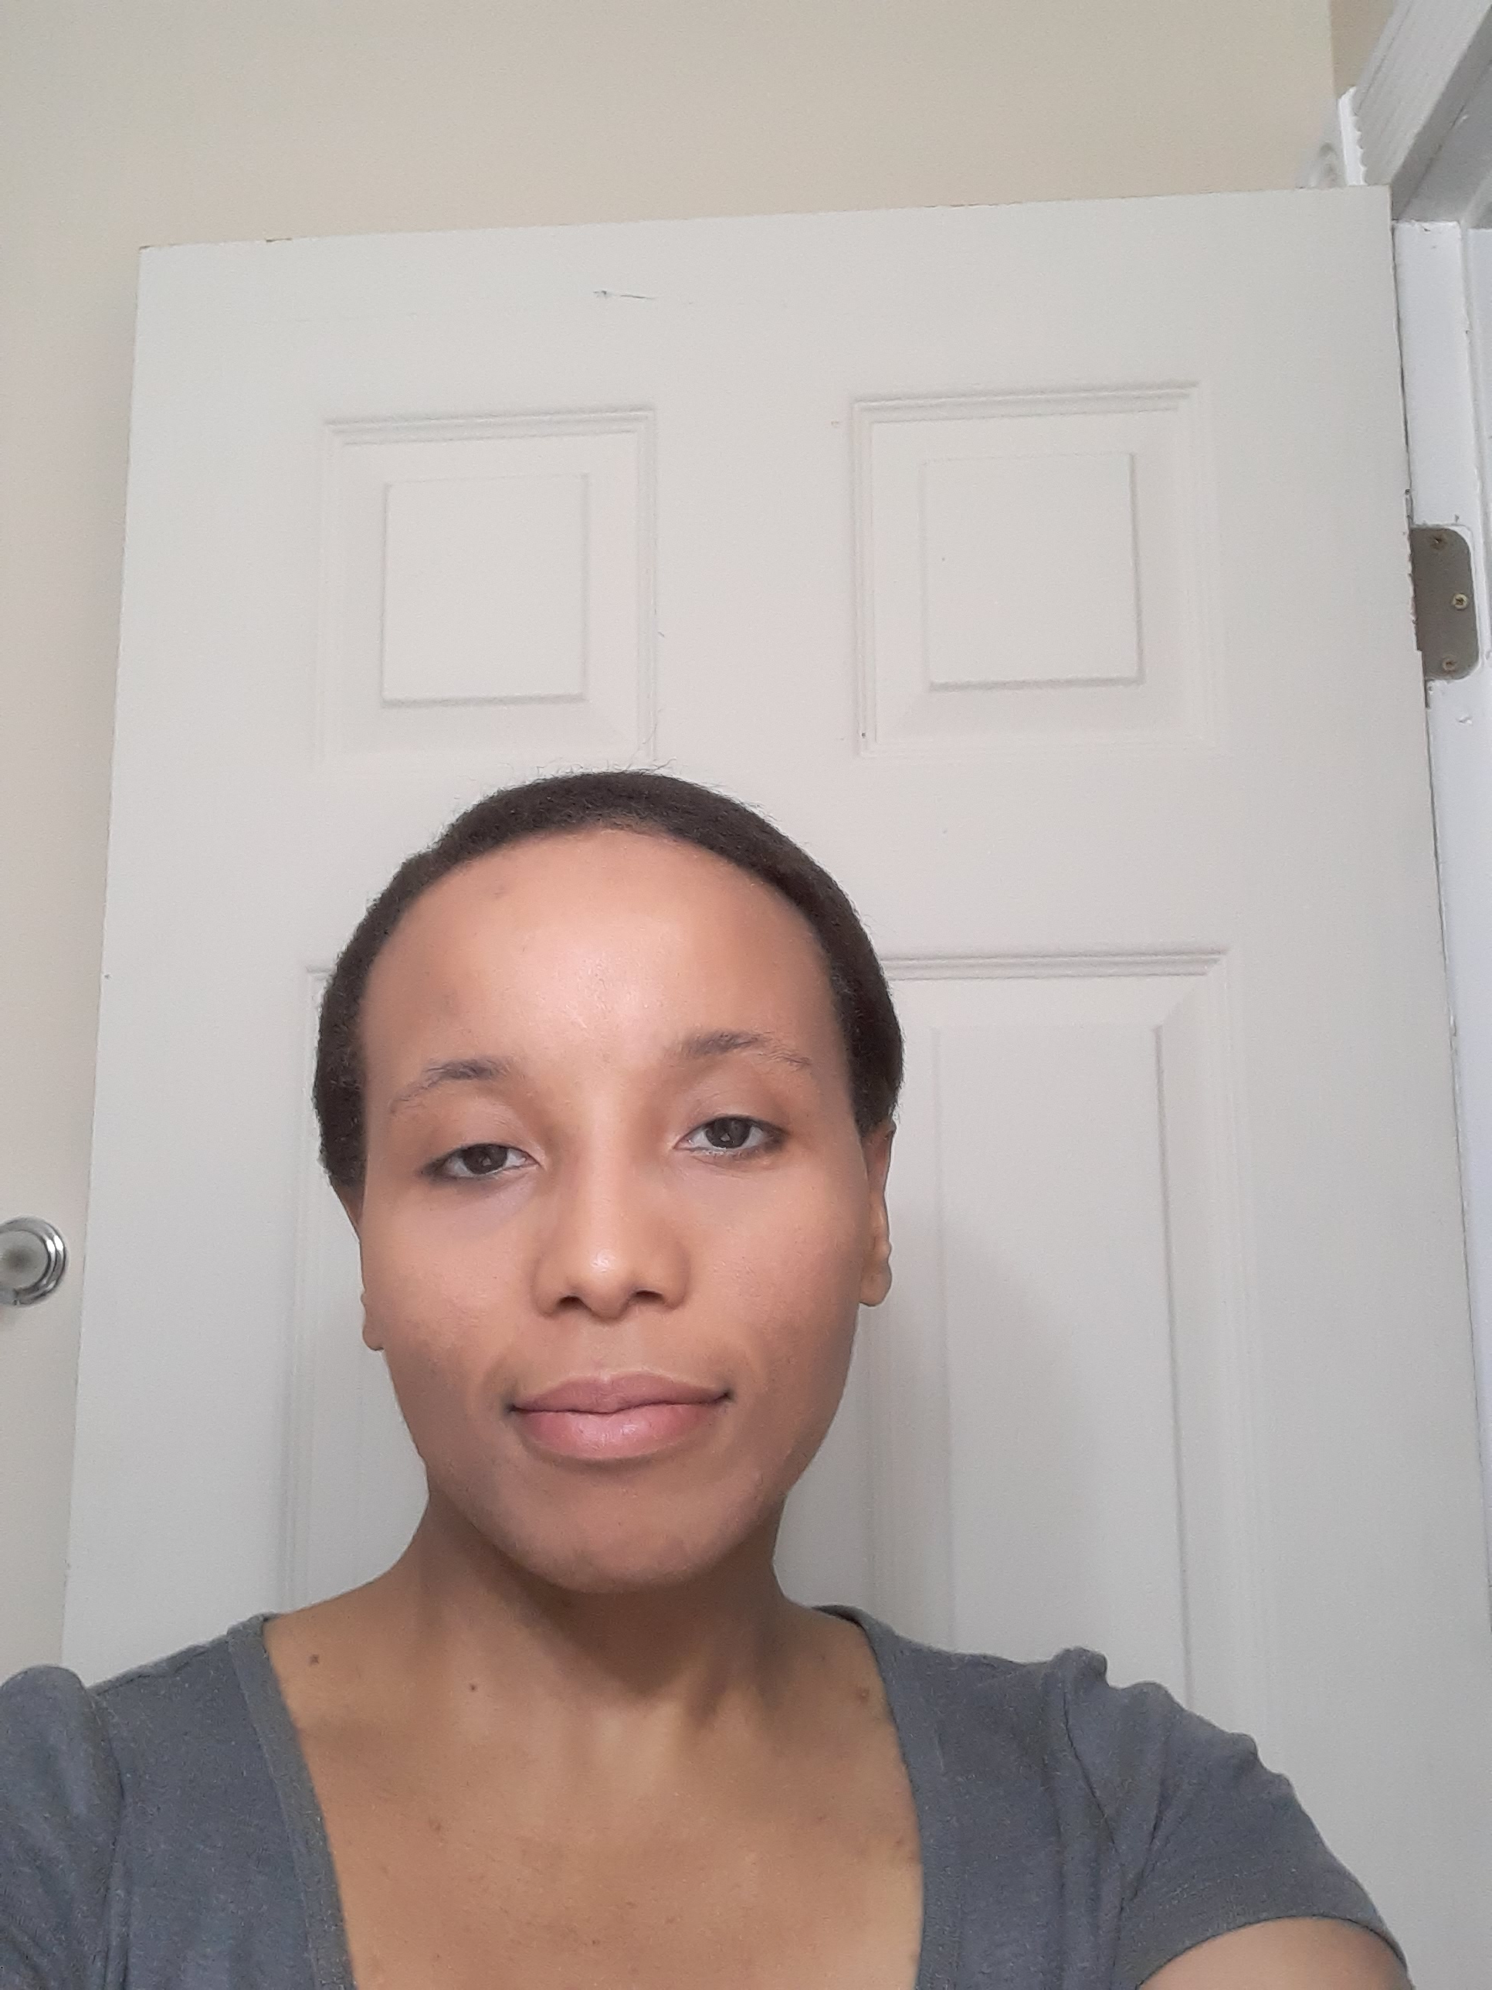 |  |  |  | Whitney Chandler

Experience
2021– Present
Package Handler• United Parcel Services, America
2023– Present
Customer Service Associate • JC Penney
2019– 2020
Customer Service Associate • Bed Bath and Beyond
2017– 2019
Data Entry Clerk • Randstad
2016– 2017
Data Entry Technician • PharMerica

Skills
- Customer Service Experience
- Phone Etiquette
- Data Entry

Education

Indiana Wesleyan University,
Master in Public Administration.

References
Please refer to “My References” are Available Upon Request
 |  | Louisville, KY
 |  | 502.414.5465
 |  | Available Upon Request
 |  | WhitneyChandler.info

