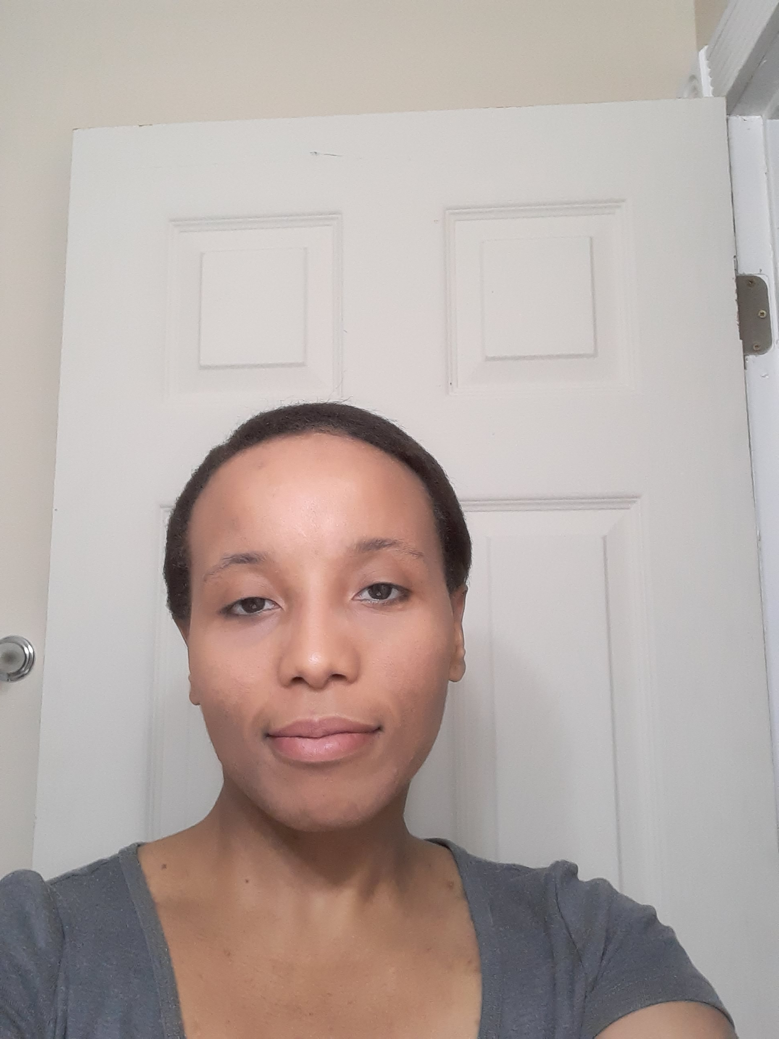 |  |  |  | WHITNEY CHANDLER’S WELL-ROUNDED PORTFOLIO

Art Work
Louisville, KY
Sketches of the Human Face

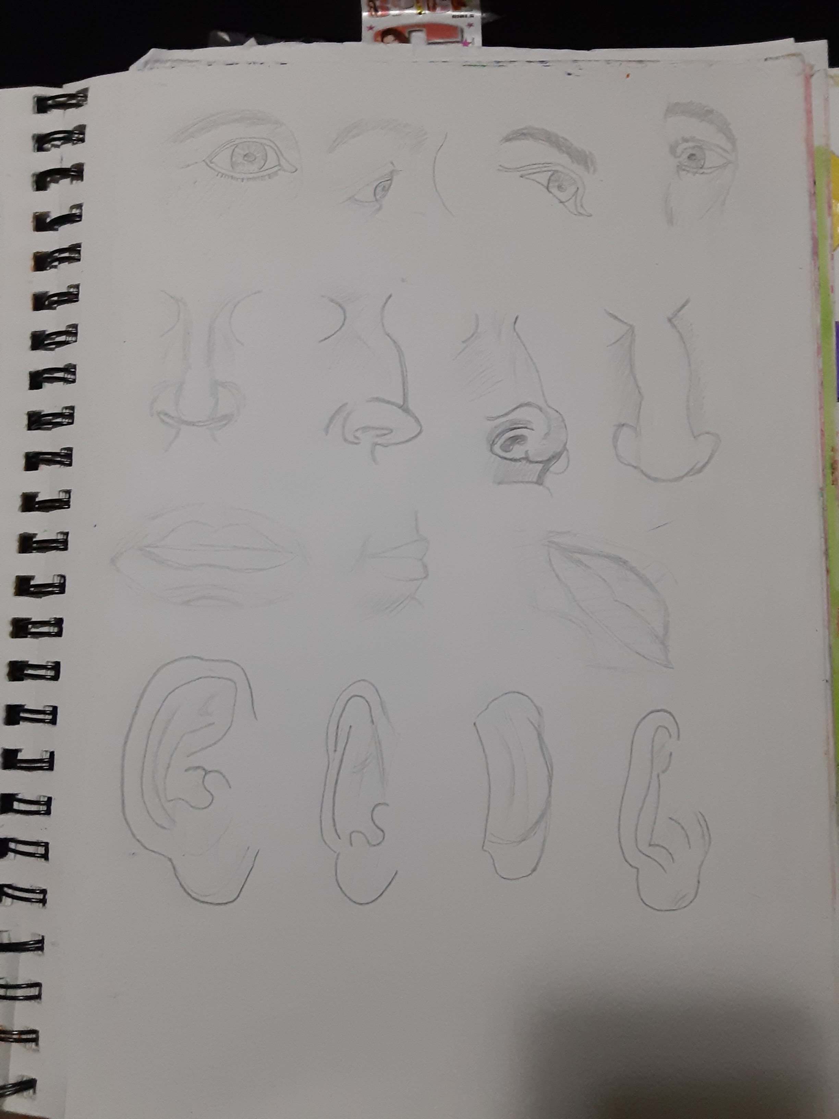About the Art Work
This artwork has a few sketches that I submitted in my high school art class.

Literary Work
Louisville, KY

Title of Literary Piece:

“Precious Languages”

About the Literary Work
This literary work was an example of my passion of learning different languages as well as traveling abroad.

More Art Works and Literary Works
[Available upon request.]
 |  | Louisville, KY
 |  | 502-414-5465
 |  | Available Upon Request
 |  | WhitneyChandler.info

